**Lab#3(a) Home Page: list few products & few menus like category, registration, sign in and about us.**

|  |  |  |
| --- | --- | --- |
| **TAGS USED** | **ATTRIBUTES USED** | **DESCRIPTION** |
| <HTML> | lang="en" | Write the description of HTML tags and attributes |
| <HEAD> | - | Contains meta-information about the document, such as title and CSS scripts. |
| <TITLE> | - | Defines the title of the document that appears in the browser's title bar. |
| <LINK> | rel, href | Links external resources, like CSS stylesheets, to the HTML document. |
| <BODY> | - | Contains the visible content of the document. |
| <NAV> | - | Defines a container for navigation links. |
| <DIV> | class | A generic container element for styling and layout purposes. |
| <A> | class, href | Creates hyperlinks and defines the URL they link to. |
| <BUTTON> | class, type, onclick | Defines a clickable button. |
| <UL> | class | Represents an unordered list. |
| <LI> | - | Represents an item in a list (<ul> or <ol>). |
| <H2> | - | Defines a level 2 heading. |
| <H5> | - | Defines a level 5 heading. |
| <P> | - | Defines a paragraph of text. |
| <IMG> | src, alt, class | Embeds an image into the document with a specified source and alternate text. |

**Final Outcome:**

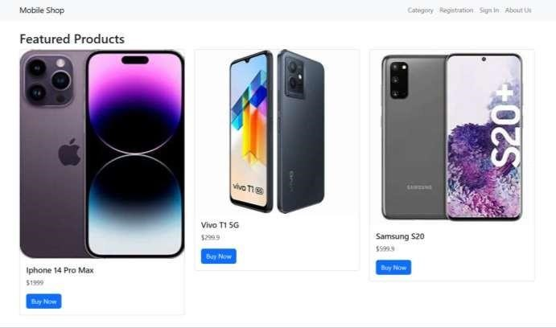

**Code Snippet:**

<html>

<head>

<title>Mobile Shopping App - Home</title>

<!-- Include Bootstrap CSS -->

<link rel="stylesheet" href="https://cdn.jsdelivr.net/npm/bootstrap@5.3.0/dist/css/bootstrap.min.css">

<!-- Custom CSS -->

<link rel="stylesheet" href="styles.css">

</head>

<body>

<!-- Navbar -->

<nav class="navbar navbar-expand-md navbar-light bg-light">

<div class="container">

<!-- Your logo/image -->

<a class="navbar-brand" href="#">Mobile Shop</a>

<!-- Navbar toggler for mobile -->

<button class="navbar-toggler" type="button" data-bs-toggle="collapse" data-bs- target="#navbarNav" aria-controls="navbarNav" aria-expanded="false" aria-label="Toggle navigation">

<span class="navbar-toggler-icon"></span>

</button>

<div class="collapse navbar-collapse" id="navbarNav">

<ul class="navbar-nav ms-auto">

<!-- Menu options -->

<li class="nav-item">

<a class="nav-link" href="P1B.html">Category</a>

</li>

<li class="nav-item">

<a class="nav-link" href="P1C.html">Registration</a>

</li>

<li class="nav-item">

<a class="nav-link" href=" P1D.html ">Sign In</a>

</li>

<li class="nav-item">

<a class="nav-link" href="#">About Us</a>

</li>

</ul>

</div>

</div>

</nav>

<!-- Main content -->

<div class="container mt-4">

<h2>Featured Products</h2>

<div class="row"> <!-- Product 1 -->

<div class="col-md-4">

<div class="card">

<img src="product1.jpg" class="card-img-top" alt="Product 1">

<div class="card-body">

<h5 class="card-title">Iphone 14 Pro Max</h5>

<p class="card-text">$1999</p>

<a href="#" class="btn btn-primary">Buy Now</a>

</div>

</div>

</div>

<!-- Product 2 -->

<div class="col-md-4">

<div class="card">

<img src="product2.jpg" class="card-img-top" alt="Product 2">

<div class="card-body">

<h5 class="card-title">Vivo T1 5G</h5>

<p class="card-text">$299.9</p>

<a href="#" class="btn btn-primary">Buy Now</a>

</div>

</div>

</div>

<!-- Product 3 -->

<div class="col-md-4">

<div class="card">

<img src="product3.jpg" class="card-img-top" alt="Product 3">

<div class="card-body">

<h5 class="card-title">Samsung S20</h5>

<p class="card-text">$599.9</p>

<a href="#" class="btn btn-primary">Buy Now</a>

</div>

</div>

</div>

</div> </div>

<!-- Include Bootstrap JS at the end of the body -->

<script src="https://cdn.jsdelivr.net/npm/bootstrap@5.3.0/dist/js/bootstrap.bundle.min.js"></script> </body>

</html>

**Lab#3(b) Categories: display few products per each category and provide show more option for complete list.**

**Final Outcome:**

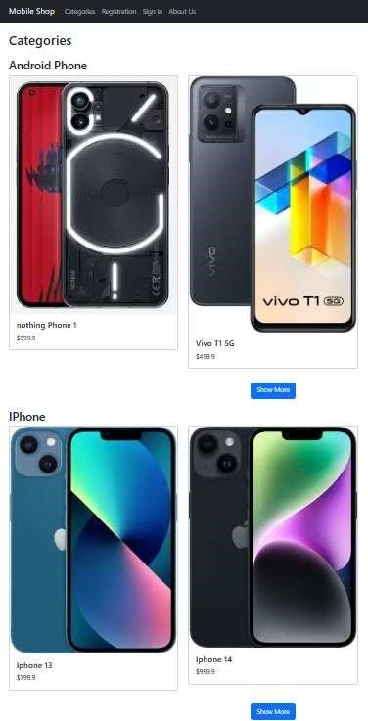

**Code Snippet:**

<html>

<head>

<title>Mobile Shopping App - Categories</title>

<!-- Include Bootstrap CSS -->

<link rel="stylesheet" href="[https://cdn.jsdelivr.net/npm/bootstrap@5.3.0/dist/css/bootstrap.min.css">](https://cdn.jsdelivr.net/npm/bootstrap%405.3.0/dist/css/bootstrap.min.css) <!-- Custom CSS -->

<style>

/* Add any custom styles here */

</style>

</head>

<body>

<!-- Navbar -->

<nav class="navbar navbar-expand-md navbar-dark bg-dark">

<div class="container">

<a class="navbar-brand" href="#">Mobile Shop</a>

<button class="navbar-toggler" type="button" data-bs-toggle="collapse" data-bs- target="#navbarNav" aria-controls="navbarNav" aria-expanded="false" aria-label="Toggle navigation">

<span class="navbar-toggler-icon"></span>

</button>

<div class="collapse navbar-collapse" id="navbarNav">

<ul class="navbar-nav ml-auto">

<li class="nav-item">

<a class="nav-link" href="#categories">Categories</a>

</li>

<li class="nav-item">

<a class="nav-link" href="#registration">Registration</a>

</li>

<li class="nav-item">

<a class="nav-link" href="#signin">Sign In</a>

</li>

<li class="nav-item">

<a class="nav-link" href="#aboutus">About Us</a>

</li>

</ul>

</div>

</div>

</nav>

<!-- Main content -->

<div class="container mt-4" id="categories">

<h2 class="mb-4">Categories</h2>

<!-- Category 1 -->

<div class="category">

<h3>Android Phone</h3>

<div class="row">

<div class="col-md-4 mb-4">

<div class="card">

<img src="category1_product1.jpg" class="card-img-top" alt="Category 1 - Product 1">

<div class="card-body">

<h5 class="card-title">nothing Phone 1</h5>

<p class="card-text">$599.9</p>

</div>

</div>

</div>

<div class="col-md-4 mb-4">

<div class="card">

<img src="category1_product2.jpg" class="card-img-top" alt="Category 1 - Product 2">

<div class="card-body">

<h5 class="card-title">Vivo T1 5G</h5>

<p class="card-text">$499.9</p>

</div>

</div>

</div>

<!-- Add more product cards for Category 1 here -->

</div>

<div class="text-center mt-2">

<button class="btn btn-primary">Show More</button>

<!-- Implement JavaScript to load more products for Category 1 -->

</div>

</div>

<!-- Category 2 -->

<div class="category mt-4">

<h3>IPhone</h3>

<div class="row">

<div class="col-md-4 mb-4">

<div class="card">

<img src="category2_product1.jpg" class="card-img-top" alt="Category 2 - Product 1">

<div class="card-body">

<h5 class="card-title">Iphone 13</h5>

<p class="card-text">$799.9</p>

</div>

</div>

</div>

<div class="col-md-4 mb-4">

<div class="card">

<img src="category2_product2.jpg" class="card-img-top" alt="Category 2 - Product 2">

<div class="card-body">

<h5 class="card-title">Iphone 14</h5>

<p class="card-text">$999.9</p>

</div>

</div>

</div>

<!-- Add more product cards for Category 2 here -->

</div>

<div class="text-center mt-2">

<button class="btn btn-primary">Show More</button>

<!-- Implement JavaScript to load more products for Category 2 -->

</div>

</div>

<!-- Add more categories with "Show More" buttons as needed -->

</div>

<!-- Include Bootstrap JS at the end of the body -->

<script src="[https://cdn.jsdelivr.net/npm/bootstrap@5.3.0/dist/js/bootstrap.bundle.min.js">](https://cdn.jsdelivr.net/npm/bootstrap%405.3.0/dist/js/bootstrap.bundle.min.js)</script> </body>

</html>

**Lab#3(C) Implement Design web pages for mobile shopping application using HTML5, CSS3 and Bootstrap 5. c. User registration web page Final Outcome:**

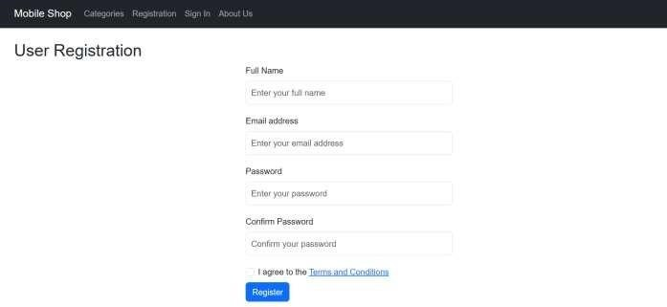

**Code Snippet:**

<html>

<head>

<title>Mobile Shopping App - User Registration</title>

<!-- Include Bootstrap CSS -->

<link rel="stylesheet" href="[https://cdn.jsdelivr.net/npm/bootstrap@5.3.0/dist/css/bootstrap.min.css">](https://cdn.jsdelivr.net/npm/bootstrap%405.3.0/dist/css/bootstrap.min.css)

<!-- Custom CSS -->

<style> body {

font-family: Arial, sans-serif;

}

form { max-width: 400px; margin: 0 auto;

}

label { display: block; margin-bottom: 8px;

}

input[type="text"], input[type="email"], input[type="password"] { width: 100%; padding: 10px; margin-bottom: 20px;

}

input[type="submit"] {

background-color: #4CAF50;

color: white; padding: 10px 20px; border: none; cursor:

pointer;

}

</style>

</head>

<body>

<!-- Navbar -->

<nav class="navbar navbar-expand-md navbar-dark bg-dark">

<div class="container">

<a class="navbar-brand" href="#">Mobile Shop</a>

<button class="navbar-toggler" type="button" data-bs-toggle="collapse" data-bs- target="#navbarNav" aria-controls="navbarNav" aria-expanded="false" aria-label="Toggle navigation"> <span class="navbar-toggler-icon"></span>

</button>

<div class="collapse navbar-collapse" id="navbarNav">

<ul class="navbar-nav ml-auto">

<li class="nav-item">

<a class="nav-link" href="#categories">Categories</a>

</li>

<li class="nav-item">

<a class="nav-link" href="#registration">Registration</a>

</li>

<li class="nav-item">

<a class="nav-link" href="#signin">Sign In</a>

</li>

<li class="nav-item">

<a class="nav-link" href="#aboutus">About Us</a>

</li>

</ul>

</div>

</div>

</nav>

<!-- Main content -->

<div class="container mt-4">

<h2>User Registration</h2>

<form>

<div class="form-group">

<label for="fullname">Full Name</label>

<input type="text" class="form-control" id="fullname" placeholder="Enter your full name" required>

</div>

<div class="form-group">

<label for="email">Email address</label>

<input type="email" class="form-control" id="email" placeholder="Enter your email address" required>

</div>

<div class="form-group">

<label for="password">Password</label>

<input type="password" class="form-control" id="password" placeholder="Enter your password" required>

</div>

<div class="form-group">

<label for="confirmPassword">Confirm Password</label>

<input type="password" class="form-control" id="confirmPassword" placeholder="Confirm your password"

required>

</div>

<div class="form-group form-check">

<input type="checkbox" class="form-check-input" id="termsCheckbox" required>

<label class="form-check-label" for="termsCheckbox">I agree to the <a href="#">Terms and Conditions</a></label>

</div>

<button type="submit" class="btn btn-primary">Register</button>

</form>

<!-- Include Bootstrap JS at the end of the body -->

<script src="[https://cdn.jsdelivr.net/npm/bootstrap@5.3.0/dist/js/bootstrap.bundle.min.js">](https://cdn.jsdelivr.net/npm/bootstrap%405.3.0/dist/js/bootstrap.bundle.min.js)</script> </body>

</html>

**Lab#3(D) Implement Design web pages for mobile shopping application using HTML5, CSS3 and Bootstrap 5.**

**d. Login page for User**

**Final Outcome:**

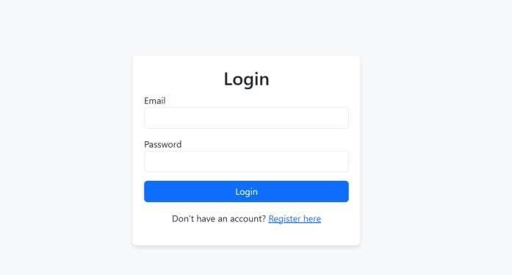

**Code Snippet:**

<html>

<head>

<title>Mobile Shopping App - Login</title>

<!-- Include Bootstrap CSS -->

<link rel="stylesheet" href="[https://cdn.jsdelivr.net/npm/bootstrap@5.3.0/dist/css/bootstrap.min.css">](https://cdn.jsdelivr.net/npm/bootstrap%405.3.0/dist/css/bootstrap.min.css) <!-- Custom CSS -->

<style>

/* Add any custom styles here */ body {

background-color: #f8f9fa;

}

.login-container { max-width: 400px; margin: 0 auto; padding: 20px; background-color: #fff; box-shadow: 0 4px 8px rgba(0, 0, 0, 0.1); border-radius: 8px; margin-top: 100px;

}

.login-container h2 { text-align: center;

}

.form-group { margin-bottom: 15px;

}

.btn-login { width: 100%;

}

</style>

</head>

<body>

<!-- Main content -->

<div class="container">

<div class="login-container">

<h2>Login</h2>

<form action="#" method="POST">

<div class="form-group">

<label for="email">Email</label>

<input type="email" id="email" name="email" class="form-control" required>

</div>

<div class="form-group">

<label for="password">Password</label>

<input type="password" id="password" name="password" class="form-control" required>

</div>

<button type="submit" class="btn btn-primary btn-login">Login</button>

</form>

<p class="mt-3 text-center">Don't have an account? <a href="#">Register here</a></p>

</div>

</div>

<!-- Include Bootstrap JS at the end of the body -->

<script src="[https://cdn.jsdelivr.net/npm/bootstrap@5.3.0/dist/js/bootstrap.bundle.min.js">](https://cdn.jsdelivr.net/npm/bootstrap%405.3.0/dist/js/bootstrap.bundle.min.js)</script> </body>

</html>

**Lab#3(E) Implement Design web pages for mobile shopping application using HTML5, CSS3 and Bootstrap 5.**

**e. Detailed product page Final Outcome:**

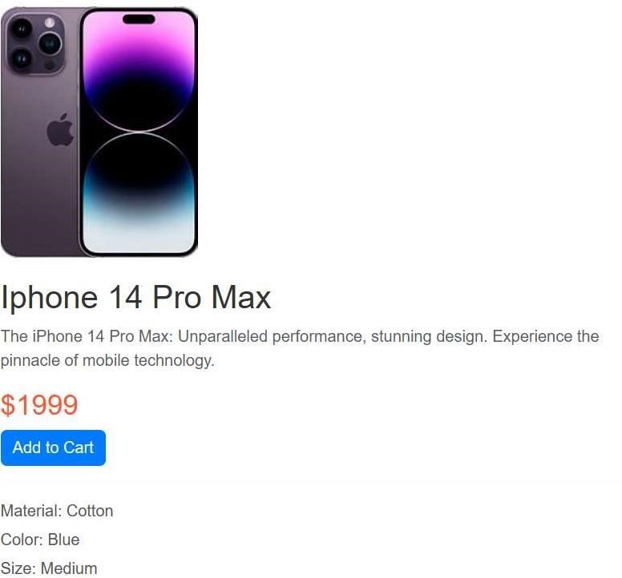

**Code Snippet:**

<!DOCTYPE html> <html lang="en">

<head>

<meta charset="UTF-8">

<meta name="viewport" content="width=device-width, initial-scale=1.0">

<title>Mobile Shopping App - Product Page</title>

<!-- Bootstrap 5 CSS -->

<link rel="stylesheet" href="[https://cdn.jsdelivr.net/npm/bootstrap@5.3.0/dist/css/bootstrap.min.css">](https://cdn.jsdelivr.net/npm/bootstrap%405.3.0/dist/css/bootstrap.min.css)

<!-- Custom CSS -->

<link rel="stylesheet" href="styles.css">

</head>

<body>

<!-- Product Page Content -->

<div class="container">

<div class="row">

<div class="col-md-6 offset-md-3">

<img src="product1.jpg" alt="Product Image" class="img-fluid">

<h2>Iphone 14 Pro Max</h2>

<p class="text-muted">The iPhone 14 Pro Max: Unparalleled performance, stunning design. Experience the pinnacle of mobile technology.</p>

<h3>$1999</h3>

<div class="rating">

<!-- You can use a rating system here (e.g., stars or thumbs up/down) -->

</div>

<button class="btn btn-primary">Add to Cart</button>

<hr>

<!-- Additional Product Information -->

<ul>

<li>Material: Cotton</li>

<li>Color: Blue</li>

<li>Size: Medium</li>

<!-- Add more details here as needed -->

</ul>

</div>

</div>

</div>

<!-- Bootstrap 5 JS and dependencies -->

<script src="[https://cdn.jsdelivr.net/npm/@popperjs/core@2.9.1/dist/umd/popper.min.js">](https://cdn.jsdelivr.net/npm/%40popperjs/core%402.9.1/dist/umd/popper.min.js)</script>

<script src="[https://cdn.jsdelivr.net/npm/bootstrap@5.3.0/dist/js/bootstrap.min.js">](https://cdn.jsdelivr.net/npm/bootstrap%405.3.0/dist/js/bootstrap.min.js)</script>

</body>

</html>

**Lab#3(F) Implement Design web pages for mobile shopping application using HTML5, CSS3 and Bootstrap 5.**

**f. Admin login**

**Final Outcome:**

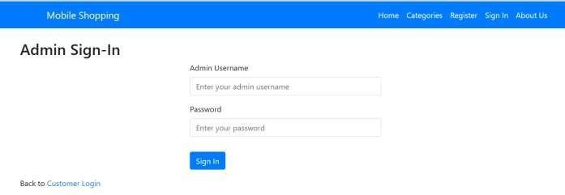

**Code Snippet:**

<html lang="en">

<head>

<meta charset="UTF-8" />

<meta name="viewport" content="width=device-width, initial-scale=1.0" />

<title>Mobile Shopping App</title>

<link rel="stylesheet" href="[https://cdn.jsdelivr.net/npm/bootstrap@5.3.0/dist/css/bootstrap.min.css"](https://cdn.jsdelivr.net/npm/bootstrap%405.3.0/dist/css/bootstrap.min.css) />

<script src="https://kit.fontawesome.com/463f82e63e.js" crossorigin="anonymous" ></script>

<script src="https://code.jquery.com/jquery-3.6.0.min.js"></script>

<script

src="[https://cdn.jsdelivr.net/npm/bootstrap@5.3.0/dist/js/bootstrap.bundle.min.js">](https://cdn.jsdelivr.net/npm/bootstrap%405.3.0/dist/js/bootstrap.bundle.min.js)</script>

<link rel="stylesheet"

href="https://stackpath.bootstrapcdn.com/bootstrap/4.5.2/css/bootstrap.min.css" />

<script src="https://stackpath.bootstrapcdn.com/bootstrap/4.5.2/js/bootstrap.min.js"></script>

<style> form {

max-width: 400px; margin: 0 auto;

}

.navbar-brand { color: #fff !important;

}

.nav-link { color: #fff !important;

}

form {

max-width: 400px; margin: 0 auto;

}

.redirect{ color: #fff;

}

</style>

</head>

<body>

<!-- Navbar -->

<nav class="navbar navbar-expand-lg navbar-light bg-light" style="background-color: #007bff !important" >

<div class="container">

<a class="navbar-brand" href="home.html" style="color: #fff">

<img width="50" /> Mobile Shopping

</a> <button class="navbar-toggler" type="button"

data-bs-toggle="collapse" data-bs-target="#navbarNav" aria-controls="navbarNav" aria- expanded="false"

aria-label="Toggle navigation"

>

<span class="navbar-toggler-icon"></span>

</button>

<div class="collapse navbar-collapse redirect" id="navbarNav">

<ul class="navbar-nav ms-auto">

<li class="nav-item">

<a class="nav-link" href="home.html">Home</a>

</li>

<li class="nav-item">

<a class="nav-link" href="categories.html">Categories</a>

</li>

<li class="nav-item">

<a class="nav-link" href="registration.html">Register</a>

</li>

<li class="nav-item">

<a class="nav-link" href="#">Sign In</a>

</li>

<li class="nav-item">

<a class="nav-link" href="about_us.html">About Us</a>

</li>

</ul>

</div> </div>

</nav>

<!-- Admin Sign-In Section -->

<section class="container mt-4">

<h2>Admin Sign-In</h2>

<form>

<div class="form-group">

<label for="adminUsername">Admin Username</label>

<input type="text"

class="form-control" id="adminUsername" placeholder="Enter your admin username" required

/>

</div>

<div class="form-group">

<label for="adminPassword">Password</label>

<input type="password" class="form-control" id="adminPassword" placeholder="Enter your password" required

/>

</div>

<button type="submit" class="btn btn-primary mt-3">

<a class="redirect" href="managment_page.html">Sign In</a>

</button>

</form>

<p class="mt-3">Back to <a href="login.html">Customer Login</a></p>

</section>

</body>

</html>

**Lab#3(G) Implement Design web pages for mobile shopping application using HTML5, CSS3 and Bootstrap 5.**

**g. Management of category & product (insert, update and delete product and categories)**

**Final Outcome:**

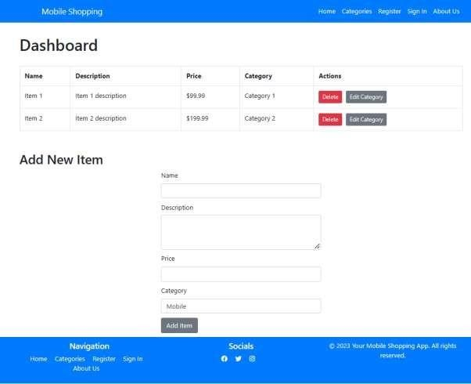

**Code Snippet:**

<!DOCTYPE html>

<html lang="en">

<head>

<head>

<meta charset="UTF-8" />

<meta name="viewport" content="width=device-width, initial-scale=1.0" />

<title>Mobile Shopping App</title>

<link rel="stylesheet" href="[https://cdn.jsdelivr.net/npm/bootstrap@5.3.0/dist/css/bootstrap.min.css" /](https://cdn.jsdelivr.net/npm/bootstrap%405.3.0/dist/css/bootstrap.min.css)>

<script src="https://kit.fontawesome.com/463f82e63e.js" crossorigin="anonymous"></script>

<script src="https://code.jquery.com/jquery-3.6.0.min.js"></script>

<script

src="[https://cdn.jsdelivr.net/npm/bootstrap@5.3.0/dist/js/bootstrap.bundle.min.js">](https://cdn.jsdelivr.net/npm/bootstrap%405.3.0/dist/js/bootstrap.bundle.min.js)</script>

<link rel="stylesheet"

href="https://stackpath.bootstrapcdn.com/bootstrap/4.5.2/css/bootstrap.min.css" />

<script src="https://stackpath.bootstrapcdn.com/bootstrap/4.5.2/js/bootstrap.min.js"></script>

<style> form {

max-width: 400px; margin: 0 auto;

}

.navbar-brand {

color: #fff !important;

}

.nav-link {

color: #fff !important;

} a {

text-decoration: none;

}

.dashboard-container { margin-top: 30px;

} h1 {

margin-bottom: 30px;

} h2 {

margin-bottom: 10px; margin-top: 50px;

}

.table th {

font-weight: bold;

}

.table-actions { display: flex;

}

.action-button { margin-right: 10px;

}

.add-item-form div { margin: 10px auto 10px auto;

}

.navigation li { display: inline-block; margin-right: 15px;

}

.social-icons li { display: inline-block; margin-right: 15px;

}

.footer {

background-color: #007bff; color: #fff; padding: 10px 0; margin-top: 10px;

}

.footer a { color: #fff;

}

</style>

</head>

<body>

<!-- Navbar -->

<nav class="navbar navbar-expand-lg navbar-light bg-light" style="background-color: #007bff

!important">

<div class="container">

<a class="navbar-brand" href="home.html" style="color: #fff">

<img width="50" /> Mobile Shopping

</a>

<button class="navbar-toggler" type="button" data-bs-toggle="collapse" data-bs- target="#navbarNav"

aria-controls="navbarNav" aria-expanded="false" aria-label="Toggle navigation"> <span class="navbar-toggler-icon"></span>

</button>

<div class="collapse navbar-collapse redirect" id="navbarNav">

<ul class="navbar-nav ms-auto">

<li class="nav-item">

<a class="nav-link" href="home.html">Home</a>

</li>

<li class="nav-item">

<a class="nav-link" href="categories.html">Categories</a>

</li>

<li class="nav-item">

<a class="nav-link" href="#">Register</a>

</li>

<li class="nav-item">

<a class="nav-link" href="login.html">Sign In</a>

</li>

<li class="nav-item">

<a class="nav-link" href="about_us.html">About Us</a>

</li>

</ul>

</div> </div>

</nav>

<!-- Admin Dashboard -->

<div class="container dashboard-container">

<h1>Dashboard</h1>

<!-- Table to display all items -->

<table class="table table-bordered">

<thead>

<tr>

<th>Name</th>

<th>Description</th>

<th>Price</th>

<th>Category</th>

<th>Actions</th>

</tr>

</thead>

<tbody>

<!-- Replace the data placeholders with actual data from the backend -->

<tr>

<td>Item 1</td>

<td>Item 1 description</td>

<td>$99.99</td>

<td>Category 1</td>

<td>

<div class="table-actions">

<button class="btn btn-sm btn-danger action-button"> Delete

</button>

<button class="btn btn-sm btn-secondary action-button"> Edit Category

</button>

</div>

</td>

</tr>

<tr>

<td>Item 2</td>

<td>Item 2 description</td>

<td>$199.99</td>

<td>Category 2</td>

<td>

<div class="table-actions">

<button class="btn btn-sm btn-danger action-button"> Delete

</button>

<button class="btn btn-sm btn-secondary action-button"> Edit Category

</button>

</div>

</td>

</tr>

<!-- Add more table rows for each item -->

</tbody>

</table>

<!-- Buttons to add new items -->

<h2>Add New Item</h2>

<form class="add-item-form">

<div class="form-group">

<label for="item-name">Name</label>

<input type="text" class="form-control" id="item-name" name="item-name" required /> </div>

<div class="form-group">

<label for="item-description">Description</label>

<textarea class="form-control" id="item-description" name="item-description" rows="3" required></textarea>

</div>

<div class="form-group">

<label for="item-price">Price</label>

<input type="number" class="form-control" id="item-price" name="item-price" required />

</div>

<div class="form-group">

<label for="item-category">Category</label>

<select id="item-category" name="item-category" class="form-control" required name=""

<option value="">Laptop</option>

<option value="">Mobile</option>

<option value="">Camera</option>

</select>

</div>

<button type="submit" class="btn btn-secondary">Add Item</button>

</form>

</div>

<!-- Footer -->

<footer class="footer text-center">

<div class="container">

<div class="row">

<div class="col-md-4">

<h5>Navigation</h5>

<ul class="list-unstyled navigation">

<li><a href="home.html">Home</a></li>

<li><a href="categories.html">Categories</a></li>

<li><a href="registration.html">Register</a></li>

<li><a href="login.html">Sign In</a></li>

<li><a href="about_us.html">About Us</a></li>

</ul>

</div>

<div class="col-md-4">

<h5>Socials</h5>

<ul class="list-unstyled social-icons">

<li>

<a href="#"><i class="fa-brands fa-facebook"></i> </a>

</li>

<li>

<a href="#"><i class="fa-brands fa-twitter"></i> </a>

</li>

<li>

<a href="#"><i class="fa-brands fa-instagram"></i> </a>

</li>

</ul>

</div>

<div class="col-md-4">

<p>&copy; 2023 Your Mobile Shopping App. All rights reserved.</p>

<!-- Add your copyright line -->

</div> </div>

</div>

</footer>

<script src="[https://cdn.jsdelivr.net/npm/bootstrap@5.3.0/dist/js/bootstrap.bundle.min.js"](https://cdn.jsdelivr.net/npm/bootstrap%405.3.0/dist/js/bootstrap.bundle.min.js) integrity="sha384-

geWF76RCwLtnZ8qwWowPQNguL3RmwHVBC9FhGdlKrxdiJJigb/j/68SIy3Te4Bkz" crossorigin="anonymous"></script>

</body>

</html>